**GREENMEADOWS SCHOOL**



**Parent Information**

**Handbook**

**2025**

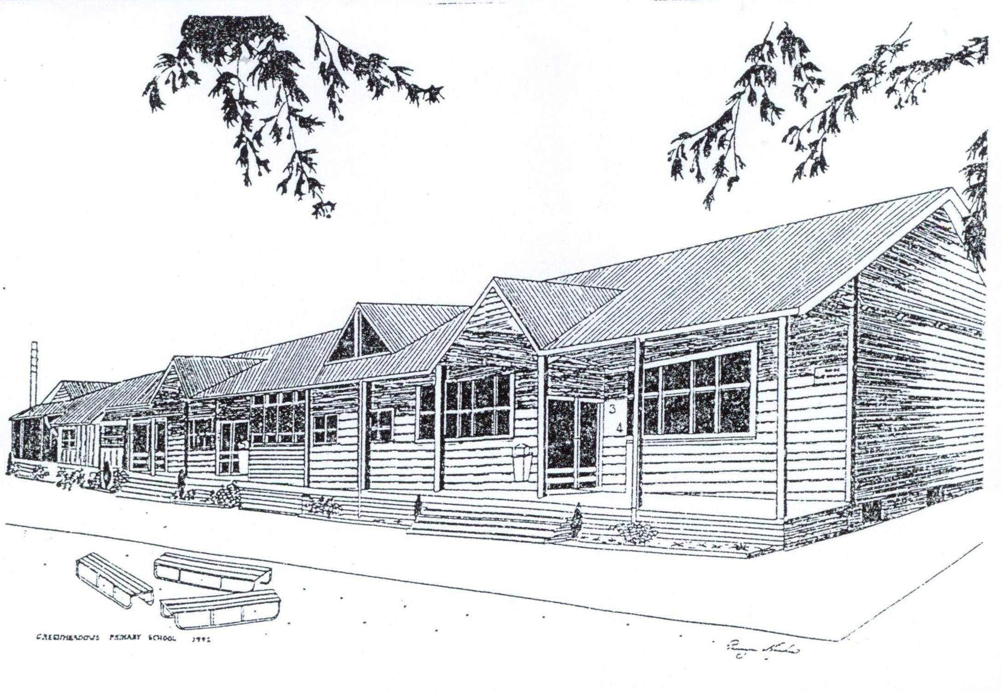

INTRODUCTION

Welcome to Greenmeadows School. Our highly regarded school is a state, contributing primary school, teaching children from New Entrants to Year 6. Students are provided with a balanced curriculum incorporating academic, cultural, sporting and social aspects of learning. Build perseverance leading to excellence in each of these areas.

Our vision for the school is encompassed in our motto: ‘**Learn Grow Achieve’**

The way we will achieve our vision is outlined in our five school focuses.

**We really believe these things and we live them every day!**

1. Child-centred programmes = success for pupils
2. The NZ Curriculum and development of key competencies
3. Belonging – we are a team and every team combines to make learning happen here
4. High Expectations - excellence, perseverance, environment, social interactions
5. Innovation – we try new ideas and keep what works

**Our core values:**

*Learn* to attain excellence (‘be the best you can’)

*Grow* respect for ourselves and others

*Achieve* through perseverance

Please do not hesitate to contact me in any way if you have questions about the school or require more information regarding your child. I look forward to working with you in a partnership to best meet your child’s needs.

Regards

Mark Johnson

Principal

Our Contact Details:

**Physical Address** **Postal Address**

Greenmeadows Primary School Greenmeadows Primary School

Osier Road P O Box 5104

Greenmeadows Greenmeadows

NAPIER NAPIER 4145

New Zealand New Zealand

Phone (06) 8447024

Email [admin@gms.school.nz](mailto:admin@gms.school.nz)

Internet home page [www.gms.school.nz](http://www.gms.school.nz)

STAFF 2025

Principal Mark Johnson

Deputy Principal Darren Holloway

Assistant Principal Allyson Ross

Assistant Principal (Junior school) Alison de Lange

Kowhai Team Coordinator Helen Harvey Room 2A Year 2

Pohutukawa Team Coordinator Sarah Groenveld Room 13 Year 3/4

Totara Team Leader Marty Gibbs Room 17 Year 6

Teacher Shari Mackay Room 1A NE/Yr 1

Anna Murphy Room 1B NE/Yr 1

Nikki Thompson Room 2B Year 2

Rochelle Ravlich Room 3 Year NE/Y1

Amy Tonks Room 4 Year 6

Bryce Lott Room 5 Year 5

Cassie Vella-Brincat Room 6 Year 3

Jane McCosh Room 7 Year 3

Shona Millner Room 8 Year 3

Ceirwyn Roberts Room 9 Year 4

Dan Ball Room 10 Year 5/6

Jane Carter Room 11 Year 5

Toni Smith Room 12 Year 4

Chris Sullivan Room 14 Year 4/5

Jan Furlong Room 15A Year 1

Lily Kay Room 15A Year 1

Nicole Johnson Room 16A Year 2

Paula Kinsey Room 16B Year 2

Part-Time Teachers Leah Hambleton CRT release teacher

Jane Lee CRT release teacher

Nikki Jeffery CRT release teacher

Leah Haronga CRT release teacher

Administration Sara Anderson Office Administrator

Carolyn Thorburn Office Administrator

Sports Coordinator Nicki Sunley

Teacher Aides Linda Cunningham

Lynne Canty

Hayley Jury

Carol Mardon

Kirsten Martin

Leanne Duncan

Vanessa Wells

Heidi Geertson

Carol Gouder

Mel White

Property Maintenance Martin Hicks

Cleaners Leanne Duncan, Debbie Johnson-Neill, Vanessa Wells

Gardener Louise Nicholson

Canteen Kim Batt

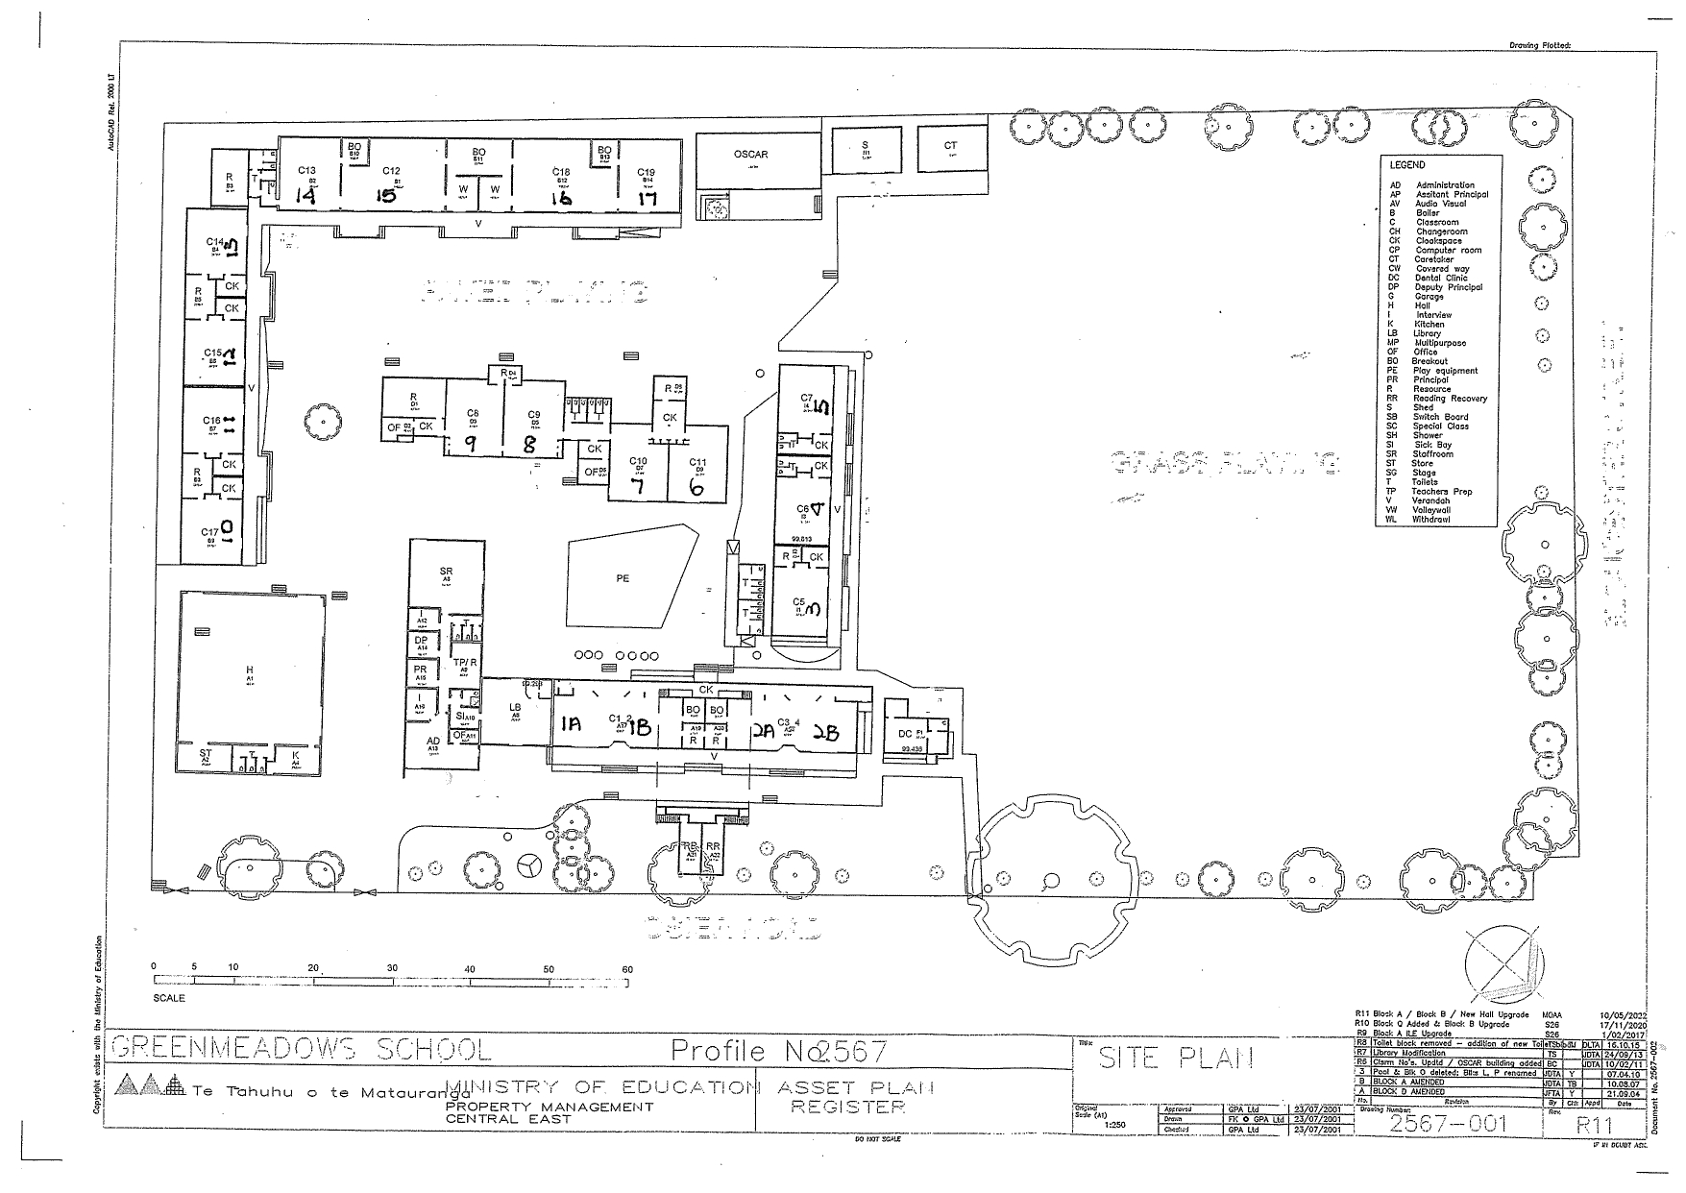

**ABSENCES AND LATE ARRIVALS**

Parents are asked to inform the school of their child’s absence by phoning the school before 9.00am or sending an email, notification on the school app. Class teachers mark attendance registers by 9.15am and 2.00pm daily. If you do not ring in and there is no response to the office phoning parents/caregivers/emergency numbers, for the safety of your child, the Truancy Service will be called. If children are late, they must come to the office and sign in. They are given a late slip for the class teacher.

If your child is away the reason for the absence of the child will be recorded by the school. The school keeps a record of absentees. The Principal follows up on persistent non-attendance.

If parents intend to take their child out of school during the day, please ensure the child’s teacher is aware of this. All children are to be signed on and out at the office. In the event of a child found missing during the day without the school’s knowledge, an attempt will be made to phone the parents. If unable to contact the parents, the Principal will ring the police unless other logical answers prevail.

**ACCIDENTS AND SICK CHILDREN**

All staff are trained in First Aid.

* ***Major accidents*** - Parents are contacted for all serious accidents or if the child falls and bangs their head. If unable to contact the parents or the emergency person listed, the child is taken to a doctor or an ambulance is sent for. During breaks duty teachers are responsible and will inform the office staff and principal.
* ***Minor accidents*** - During breaks duty teachers will send the child to the office where the child will be treated.
* ***Sick children*** - Pupils are taken to the medical room and parents contacted. If parents are unable to be contacted the emergency contact is notified to collect the child.

Accidents are recorded in the accident register held in the medical room. This is reviewed regularly

**ASSEMBLY**

There is a school assembly every second Friday at 12.15pm.

**BELL TIMES**

8.30am School opens for children

9.00am Classes begin

11.00 - 11.20am Interval

12.50 - 1.40pm Lunch

2.50pm School finishes for Kowhai (Rooms 1A,1B,2A,2B,3,15A,15B,16A,16B)

3.00pm School finishes for rest of school

Children must leave the school grounds immediately after the end of school unless attending organised sports training or OSCAR. Unless supervised by parents, children are not to be in the school grounds before 8.30am or after 3.15pm without prior arrangement.

**BICYCLES**

Cycles should meet safety standards and be checked at regular intervals. Children should know the rules of the road and be mature enough to handle a cycle safely. It is the recommendation of the New Zealand Police that children under the age of 10 should not be allowed to cycle to school unaccompanied.

The use of safety helmets, properly fitted at purchase, is compulsory for all cyclists.

Bicycles are put in the bicycle stands behind Room 17.

**BOOK CLUB**

Book Club catalogues come home with your child four times per year.  This gives you the opportunity to purchase great books at a good price while supporting our school.  GMS receives 20% of all sales to purchase books for our school library.

Ordering and paying is done by visiting scholastic.co.nz/LOOP or download the app. Your order will be electronically linked to the rest of the school’s order.

All orders are delivered to the school and will be given to your child in their class. If you wish for your order to be a gift, then mark it as ‘gift’ when ordering and we will keep your order in the office for you to collect.

**BUDDY CLASSES**

This system operates on a regular basis. Senior and middle classes are matched up with a junior class and share aspects of their work and other activities.

**CLASS TRIPS & PRODUCTIONS**

The Board of Trustees gives approval for all school trips, delegated to the Principal through our Education Outside the Classroom Programme.

**TRIPS**

If classes go on a trip this will be advertised in the school newsletter or a separate notice will come home. Some trips require prepayment (especially school camps) while others will have the costs invoiced. If families choose not to include their child in any activity requiring payment, they must inform the school office or class teacher in writing prior to the activity.

**SUPERVISION**

The usual supervision ratios on outings are:

* 1:5 adults to pupils (including teachers) in the Junior/Middle school
* 1:10 adults to pupils (including teachers) in the Senior school.
* 1:5 adults to pupils for excursions involving water.

These ratios are determined by senior staff and can vary depending upon safety needs and behavioural requirements in each instance. Signed parental permission slips for all activities away from school are a requirement of pupils going on these excursions, depending on the various levels of the EOTC activity concerned.

Upon enrolment parents are required to sign a permission form that gives consent for each child to be involved in Level 1 and 2 activities without an individual return form. Higher risk activities are notified in advance and require separate permission forms.

**COMPUTER BASED LEARNING**

Computers and other communication technologies are used throughout the school to support learning. All children have access to these resources. All rooms have iPads, Chromebooks provided by the school and access to computer laptops to support their learning.

**DENTAL CLINIC**

Regular dental care is provided free of charge for all school and pre-school children, at Greenmeadows School. If you have any queries or concerns contact the Dental Therapist on 8447023, If they are not available at Greenmeadows School please phone the Tamatea Intermediate Dental Clinic on 8734864 or Onekawa Dental Clinic on 8734863.

**DISCIPLINE**

The school has a Behaviour Management Programme and supporting procedures that encourage children to develop a positive self-image and good social skills through a school wide programme. All teachers follow these procedures.

Children are shown there are clear consequences, both positive and negative, for their actions. Unacceptable behaviour is dealt with appropriately.

**EMERGENCY PROCEDURES**

Evacuation procedures are well known to all our children and are approved annually by the Fire Service.

The decision will be made to evacuate upon advice from the Civil Defence, an announcement on the radio or a large earthquake.

A verbal warning will be issued by senior management and office staff to students and staff present at school, to evacuate the site to higher ground.

Parents will be notified through the school App and/or a text. From the initial contact, parents will be regularly updated via alerts through the App.

Teachers are to collect registers and assemble children quickly on the school field. All children and staff will be accounted for before departing on foot to our designated evacuation site for Tsunami warnings.

**Our evacuation site is at the rear of Church Road Winery, 150 Church Road, Taradale**.

Students and staff will walk up Osier Road, through Knightsbridge to the rear of Church Road Winery. Senior staff will arrange a vehicle for any students/staff who are incapacitated or unable to walk.

In the case of a distant earthquake civil defence may organise buses to transport local schools to our evacuation point. In the case of a local tsunami we will move quickly by foot to our evacuation point.

All staff and students will again be accounted for once assembled at the evacuation site on Church Road.

Parents must collect their children from the evacuation area, not from school. For everyone’s safety parents must not try to come to school and not try to collect their child on route to the evacuation point.

**ENROLMENT**

It is best if children are enrolled before their starting date. This provides time for consultation and ensures correct classroom placement of the pupil. Forms and details are available from the office. All prospective parents are invited to meet with the Principal and have a tour around the school.

**New Entrants**: Parents will be contacted regarding school visits prior to their child stating school. School visits are held on a Wednesday from 9am till 11.30am in our Oscar room. A birth certificate or passport is necessary for verification of the child’s date of birth prior to starting school (MOE requirement). An Immunization Certificate is also required. If your child is not immunised, parents are asked to provide a letter to the school stating that their child is not immunised by parental choice.

**ENROLMENT ZONE**

Due to considerable roll growth over recent years the school was forced to put in place an enrolment zone from early 2013. Please refer to the information related to the school zone, and the current availability of places for out of zone enrolments.

**HEALTH NURSE**

Jesse Hohaia-Hall, our Public Health Nurse sees to any queries or requests and makes regular visits to the school. She can be contacted by phoning Community Health on 8341815 or emailing the school office.

**HEARING AND VISION**

The local District Health Board provides trained people to test New Entrant pupils’ hearing and vision. Teachers also refer pupils they have concerns about.

**KEEPING IN TOUCH WITH PARENTS**

**Open Door:** The school maintains a very welcoming ‘open door’ policy. If you need to discuss anything relating to your child with his/her teacher, you are encouraged to see the teacher and make a time to discuss the matter.

**Newsletter -** There is a fortnightly newsletter sent out on alternate weeks with an overview of events from the Principal, Staff, Board of Trustees and Parent Teacher Association. This is sent with the oldest, or only, child in the family. These are sent electronically and copies of are all are found on the school’s website. Specific events are also notified in the newsletter, but if they require more detail parents will receive a notice from the teacher(s) in charge of the event. Urgent notices will be sent home as needed.

**LOST PROPERTY**

All clothing, including swimwear, hats, shoes, coats and jackets should be clearly named. When naming school bags remember to name them clearly on the inside.

Lost property is stored in a rack next to room 9.

**LUNCHES**

Lunch break is normally from 12.50pm to 1.40pm but may be changed to suit special circumstances, such as school trips or inter-school sports.

LUNCH SYSTEM

Greenmeadows School runs a canteen from the kitchen three days a week – Wednesday, Thursday and Friday.

The procedure for ordering lunches or morning tea is as follows:

Register online for Kindo.

This can be found on our school website under the canteen tab.

Once you have registered you can view the menu and order lunch online. Kindo is also used to register for your child’s sport.

**We ask that children do not bring lollies to school.**

**MEDICAL**

Please inform the school of all allergies or conditions that may require special attention and/or treatment in an emergency or restrict the child’s participation in normal school activities.

If your child ***IS TAKING ANY MEDICINE*** that could affect his/her behaviour please tell their teacher. Medicines, tablets and asthma inhalers or similar can be brought to school. Please provide the teacher and office with written permission to dispense this medicine on a form available from the office. Instructions in the dosage/use of medication must be given.

**Sickness -** Please keep unwell children home. If the complaint is infectious please let us know and check with your doctor or the school before allowing your child to return. A recommended period of absence list is held in the office.

**Head lice** are a recurring problem. Please check your child(ren) regularly. Your chemist or doctor will advise treatment. In fairness to others, we send home a notice with each class pupil advising parents to check heads when headlice are seen or reported. A battery-operated nit-comb can be borrowed from the office, free of charge. An agreement is signed by the user to replace the comb if broken.

**Immunisation certificates** need to be presented on 5 year old’s entry to school. Your child’s immunisations will then be recorded in the school’s immunisation register.

**MUSIC**

Our school is fortunate to have a choir, ukulele playing group, Maori cultural group, and dance and drama groups. We take part in the combined schools Music Festival and the Taradale Maori Cultural Festival.

**NON-SMOKING**

Greenmeadows School is a non-smoking environment as required by law. This means **no one may smoke in the school grounds or buildings** at any time.

**OSCAR – AFTER SCHOOL CARE**

OSCAR operates out of their own room on the edge of the school field. They offer care for children before, after school, and during the holidays.

OSCAR runs between 7.30am and 8.30am before school and between 3.00pm and 5.30pm during the term and between 7.30am & 5.30pm in the holidays. Please contact OSCAR for vacancies in enrolments as there can be a long waiting list. For more information contact Tina Green 027 603 4568 or [gmoscar@xtra.co.nz](mailto:gmoscar@xtraco.nz)

There is often a lengthy waiting list for our school’s OSCAR. Contact the school office if you want to get information about alternate after school care facilities or check the school website.

**PARENT HELP**

There are a number of ways parents can become involved in the school. Here are just a few:

* Parent Teacher Association
* art and craft hobbies
* assisting at sports days
* assisting with sports coaching
* trips - supervision and transport
* reading mileage
* Camp – parent helpers
* classroom help

If you are able to help, make your selection from this list or ask your child’s teacher. You will be welcomed with open arms!

**PARKING**

Please do not double park in Osier Road or park on the yellow lines as it obstructs the Road Patrol children in carrying out their duties. Also please do not park in or across the driveway of the Childcare Centre, which is located next to the school. There is also a disabled parking space outside the school – please ensure this is reserved for those entitled to use it.

We are fortunate that those associated with St Mary’s Church permit our families to use the church car park spaces. Please respect these arrangements. Also do not park on the grassed areas of the church. Due to past parking problems, St Mary’s church has restricted the use of their car park. We abide by the notice issued by the Parish Manager as follows:

**‘PARISH NOTICE’**

* Parking for parents/staff/school visitors is absolutely prohibited whilst the funeral or church signs are displayed.
* Except for those people granted an exception, parking before 10.00am and between 2.30pm and 3.30pm school days must be restricted for ‘pick up’ or ‘putting down’ of children. (This will be monitored regularly).

**PLAYING FIELD AND COURTS**

The school is fortunate in having large playing fields and hard court areas. These are fully utilised for Physical Education, Sports and play.

**ROAD PATROLS**

The school operates two Road Patrols, one on the Gloucester Street crossing (one of the busiest in Napier) and one on Osier Road. Children, trained by NZ Police Traffic Officers, operate these crossings

**SCHOOL FEE DONATION**

There are no school fees requested by our school in 2023.

**SCHOOL LIBRARY**

To ensure children make as much use of the library as possible, each class is timetabled to have at least one library time per week. In addition, staff use various ways to encourage children to become readers and research users of the library. All children are required to have a book bag to issue a book.

Children will be issued books if they do not have any overdue books. If an overdue book cannot be found you will be invoiced for the books replacement value. No further books will be issued until payment of the lost book is received or the book is returned.

**SCHOOL EXTERNAL SUPPORT AND GUIDANCE**

Resource Teachers of Learning and Behaviour (RTLBs) are available to help the school and whanau plan to meet educational concerns for all children where there is a need. This may be a developmental delay, learning or behaviour difficulties or physical disability. Children may be referred for a wide range of reasons. Prior to any referral there is full consultation and agreement with parents and teachers over the best course of action to take. Any referral is done through the class teacher or SENCO.

**SPECIAL ABILITIES**

Some learners have above average ability, creativity and task-commitment in one or more areas, e.g. academic, social and physical, art or musical areas.

One of the main aims of this school is to cater for children’s needs at appropriate levels as identified by teachers, caregivers or helping agencies. This is done though the school’s curriculum plan and Special Needs Coordinator. Classroom special programmes will cater for the varied needs of the pupils. There is a requirement for schools to document how they will provide for the needs of their gifted and talented students.

**ADDITIONAL NEEDS**

It may be necessary to contract help from outside the school e.g. Ministry of Education Special Education. The child(ren) may work with a teacher or teacher aide, trained in the skills needed to accelerate their learning and progress in these areas.

Teachers refer children with additional needs to the appropriate service after full consultation with parents and caregivers.

Assistance may be one-to-one, small groups or working with outside agency professional.

Individual Education Programmes (IEPs) for students are written in which parents, psychologist, teachers, specialist itinerant teachers and other professionals are involved. Pupil’s progress is carefully monitored and reported on at these meetings.

**SPORTS**

We encourage participation in a wide range of sports and offer the following sports when we have sufficient parent, pupil or teacher interest:

* Athletics
* Basketball
* Cricket
* Cross Country
* Canoe Polo
* Hockey
* Netball
* Rugby
* Soccer
* T-Ball
* Rippa Rugby
* Volleyball

Other sports can be added where interest is shown.

Practices are taken by arrangement with the coach and may be during lunch hour, or after school. We also compete in inter-school competitions such as the Spooner Shield and other district events.

Sports registrations are now done on Kindo. Payment is required at time of registration. The link to register for this is found under the sports tab on our school website.

**CANCELLATIONS**

If an after-school sports practice is to be cancelled, the decision will be made by the coach and passed on to the sports coordinator and the office, usually by 1.50pm. If possible we will use our App to inform our parents about any cancellations.

**STATIONERY**

All children’s stationery requirements can be purchased from Office Products who hold stocks of our school stationery packs. They are found at 44 Wakefield Street, Onekawa, Napier.

Getting stationery is a very simple process – go to Office Products and tell them which class your child is in and they will provide you with the set requirements. We note that supplies purchased as cheaper options from other stationery outlets are often of inferior quality, so we urge you to use our preferred supplier.

A stationery list is supplied to all children prior to the beginning of the year, and for all new children enrolling during the year.

**SWIMMING**

Swimming is part of the school programme. All swimming instruction takes place at the Dolphin Academy (the old Greendale Pools) in Taradale. You will be notified when the swimming for the class your child is in is due to commence.

Please send your child with togs on the days they swim. If children are unable to swim for health reasons a note is required. Your child will receive a notice when swimming is due to start.

**SCHOOL APP**

We have our own school app - to download visit the Apple ‘App store’ or the Android ‘Play Store’ and search for ‘Schools App NZ’, download and type in Greenmeadows School to install. This free App lets you receive notifications about school events, newsletters, sports notices, etc. These go straight to your phone.

**WET DAYS**

We do not shorten our lunch hours on wet days, thus, there is no early closing.

**UNIFORMS**

An attractive and practical school uniform is available from The Warehouse in Napier or you can order online at www.thewarehouse.co.nz/c/schools/greenmeadows-school. This is compulsory for all children. Those children representing the school in sporting or cultural events are to be dressed in the uniform as set out for their team. You are not required to buy your child a sports top, these are issued by the school.

*Any other questions about our school? Try these:*

* *look at our school website,*
* *look us up on Facebook,*
* *give us a ring,*
* *send an email or*
* *simply pop into school.*

*We look forward to hearing from you.*